Contents
1 19.06 to 29.06: Procedural Programming 2
1.1 Learning Ressource 2
1.2 Task 2
2 29.06 to 19.07: Object Oriented Programming (OOP) 3
2.1 Learning Ressource 3
2.1.1 Mandatory 3
2.1.2 Additionally: inLearning Videos 3
2.1.3 Additionally: YouTube 3
2.2 Task 3
2.2.1 Mandatory (Idea, not for the actual course!) 3
2.2.2 Additionally 4
3 19.07 to 20.07: Tower of Hanoi (optional) 5
3.1 Scenario 5
3.2 Task 5
4 20.07 to 28.07: SQLite (optional) 6
4.1 Learning Ressource 6
4.1.1 Basics 6
4.1.2 Additionally 6
4.2 Task (between 1 hrs and 2,5 days) 6
5 20.07 to 28.07: Recap (optional) 6
6 Problem solving skills 8
6.1 What is 8
6.2 Develop Problem Solving Skills 8

19.06 to 29.06: Procedural Programming

Learning Ressource
All necessary contents can be found in the .pdf file "Python_p1-p194". Work through all content and all exercises. Remind yourself: The activities are not optional.

Task
- Develop a Python quiz program.
- All central contents of pages 1-194 should be addressed.
- Your quiz program must be tested and executable.
- Upload your quiz program to Moodle by 28.06.2023.
Nomenclature of the file to be submitted in .py format:
FirstName_LastName.py. Example: Peter_Kocmann.py

29.06 to 19.07: Object Oriented Programming (OOP)

Learning Ressource

Mandatory
OOP: Working with Classes by Corey Schafer
UML Class Diagramm by Lucid Software

Additionally: inLearning Videos
Attention! The access is free of charge for one week as a trial access. Disadvantage: Payment data must be entered when registering. This also applies to the free trial week. Make sure that you do not unintentionally take out a subscription.
Programming Foundations: Object-Oriented Design by Barron Stone and Olivia Chiu Stone
Python Object-Oriented Programming by Joe Marini

Additionally: YouTube
- UML Use Case Diagramm by Lucid Software
- UML Sequence Diagram by Lucid Software

Task

Mandatory (Idea, not for the actual course!)
The subject area is simple cost accounting for hospital patients.
- Is the UML class diagram shown logically and syntactically correct?
- Re-create the diagram, corrected and improved if necessary. Uses draw.io as tool
- Program the class diagram and check its executability with debugging techniques.
- Submit your program in the .py file format.
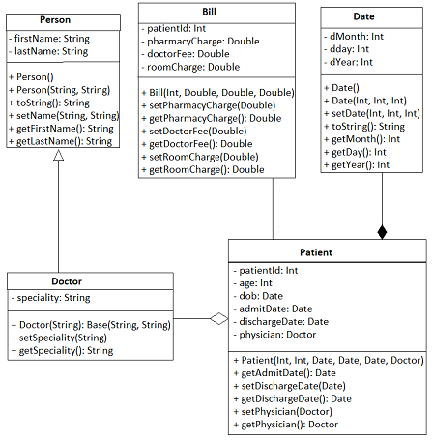

Additionally
- Watch the Video about Shreksapawn. Shreksapawn addresses machine learning as a game in a simplified form.
- Program the game Shreksapawn (aka Hexapawn) using object-oriented programming. The programming effort for newbies is about 1.5-2 days.
- Upload the finished and executable game as a .py file.
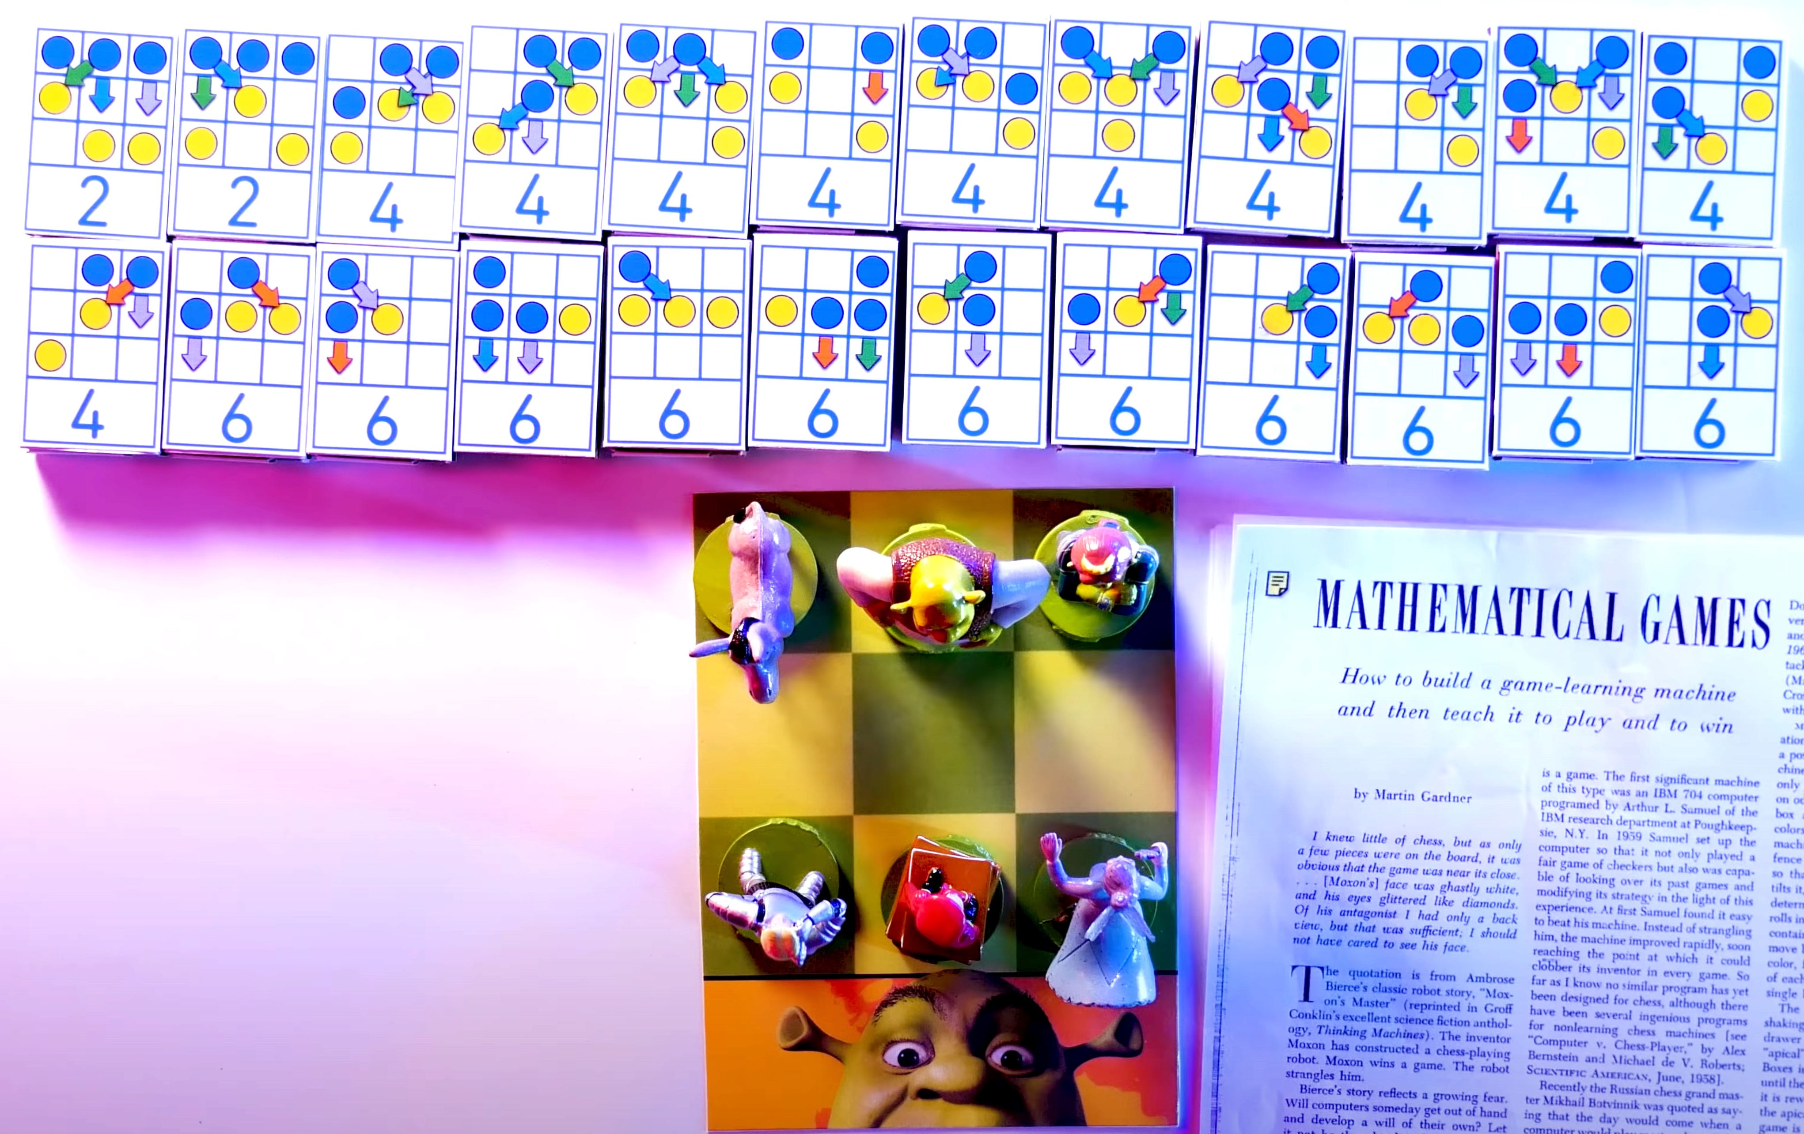

Hexapawn is a simple example of machine learning because it involves the use of an algorithm that "learns" from its past experiences. More specifically, the machine player (in our case) updates its knowledge based on the outcomes of the games it plays. Here's a breakdown of the learning process in the Hexapawn game we've developed
- Initially, the machine does not have any strategy or knowledge and plays moves randomly.
- After each game, the machine checks if it has lost. If it did lose, it remembers the last move it made and adds it to a list of "forbidden moves". This means it learns from its mistake and will avoid making that move in similar future situations.
- As the machine plays more games, it continues to accumulate knowledge about which moves lead to losses. It uses this knowledge to improve its play, thus exhibiting a basic form of learning.
- It's important to note that this is a very rudimentary form of machine learning. The learning is explicit and rule-based, meaning that the machine simply follows the instructions we've given it to update its list of forbidden moves. This is quite different from more advanced machine learning techniques which involve complex models, large datasets, and statistical learning methods to gradually improve performance on tasks.
Nevertheless, the Hexapawn game provides a nice, simple demonstration of the core idea of machine learning: that a system can improve its performance on a task over time by learning from its experiences.

19.07 to 20.07: Tower of Hanoi (optional)

Scenario
Three vertical bars (henceforth "towers") stand next to each other. We call them A, B, and C. Tower A is surrounded by donut-shaped discs. The disc with the largest diameter is at the bottom, and we call it disc 1. The discs above disc one are numbered in ascending order as their diameter decreases. For example, if we work with three discs, the one with the largest diameter at the bottom is called 1.
The disc with the next most minor diameter, disc 2, would be on disc 1. And finally, the disc with the most minor diameter, disc 3, would be on disc 2. We aim to move all the discs from Tower A to Tower C, subject to the following restrictions:
- Only one disc may be carried per turn.
- Only the top disc on each tower is available for movement.
- A disc with a higher diameter may never lie on one with a lower diameter.


Task
Solve the puzzle with Python.
Use object-oriented programming.
Use a UML class diagram to describe it.

20.07 to 28.07: SQLite (optional)

Learning Ressource

Basics
Create Quick Databases with Python and SQL by PythonSymplified

Additionally
SQLite Tutorial by Corey Schafer
SQLite Tutorial (Webpage as a complete SQLite Course)
Erste Normalform by BildungInteraktiv
Zweite Normalform by BildungInteraktiv
Dritte Normalform by BildungInteraktiv
Entity Relationship Diagram (ERD) Part 1 by Lucid Software

Task (between 1 hrs and 2,5 days)
Create an example database on the base of the data from the FiveThirtyEight Comic-Article. The database to be created don’t has to be huge. Decide by yourself which amount of time you’re interested to invest in this project.
Output: Al least a .py-file. If you’re comfortable with going forward than provide an UML-Diagram as .png-file, an ERD Diagram as .png-file and perhaps a short Documentation as .pdf-file.

20.07 to 28.07: Recap (optional)
Utmost important: Repetition of content that has not yet been understood with certainty. Recommandation: LeetCode

Die restlichen Selbstlern-Aufgaben im Rahmen eurer Zeitangaben und angereichert mit fakultativem Material lade ich Sonntag hoch.

Problem solving skills

What is
Problem-solving competence in data science refers to the ability to effectively identify, analyze, and solve complex problems using data. It involves technical skills, critical thinking, and domain knowledge to derive insights and make informed decisions.

Develop Problem Solving Skills
To develop problem-solving competence as a data scientist:
Practice Real-world Projects: Engage in hands-on projects to solve real problems using data. This practical experience will sharpen your problem-solving skills.
Collaborate and Learn from Others: Collaborate with fellow data scientists, participate in forums, and learn from their approaches and solutions to different problems.
Continuously Learn: Stay updated with the latest advancements in data science. Take online courses, read relevant books and articles, and explore new tools and techniques.
Solve Diverse Problems: Challenge yourself by tackling a wide range of problems in different domains. This broadens your problem-solving abilities and exposes you to different scenarios.
Analyze and Iterate: Analyze your problem-solving approaches and learn from your mistakes. Iterate on your solutions, seeking optimization and efficiency.
Remember, problem-solving is a skill that improves with practice. By actively working on projects, learning from others, continuously expanding your knowledge, and reflecting on your experiences, you can enhance your problem-solving competence as a data scientist.

