Shreksapawn

The program …

* must play shreksapawn
* Must get better at the game
* should register and keep track if user or system won

User Story:

As a user…

* I want to play the game
* I want to know who won
* I want to know how many times I have won already

Use cases

* PlayGame; user
* Success scenario: User sees game board, user moves piece, system registers move, system identifies constellation, system moves piece, [repeat process], system registers winning situation, announces winner, announces winning history

Objects: user, piece, game board, constellation (strategy), counter

First draft UML diagram:

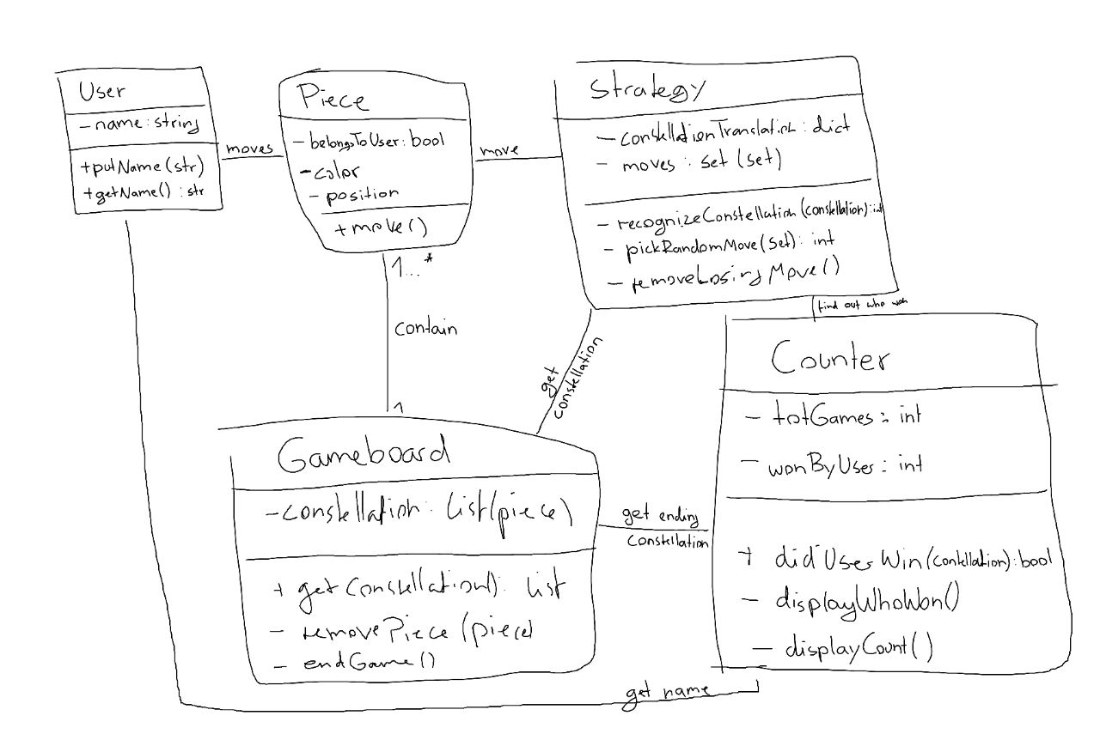

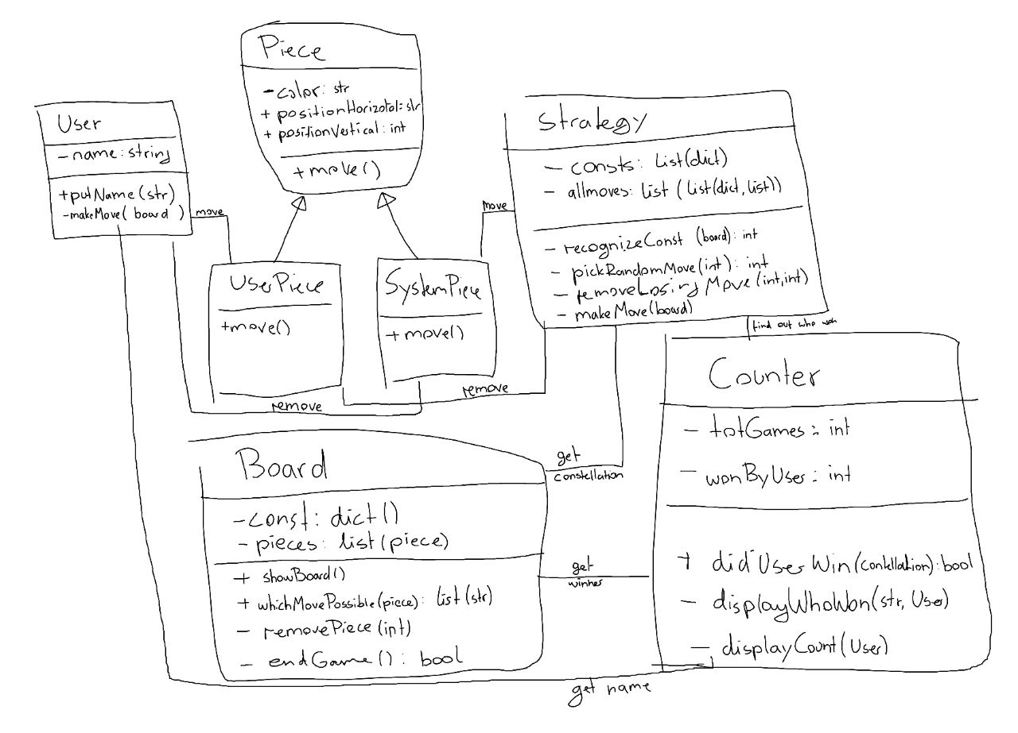Final UML diagram: